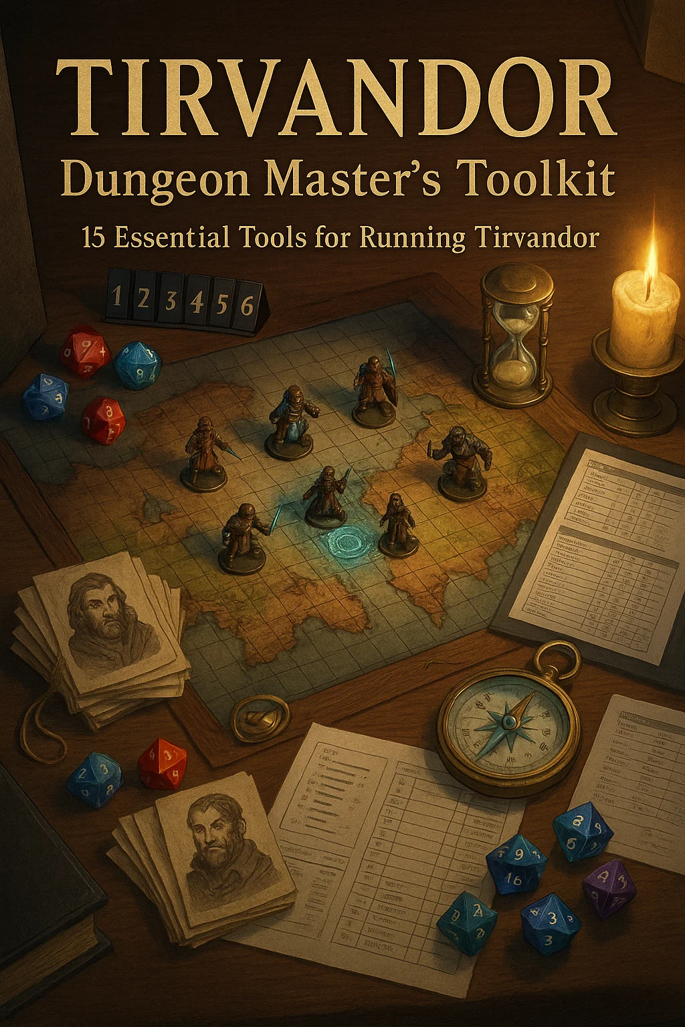

*© 2024-2025 Tirvandor Campaign Setting. All rights reserved.  
For personal tabletop use only. Not for commercial distribution.*

# Magic Item Cards

Complete Collection - 3x3 Grid Format

|  |  |  |
| --- | --- | --- |
| **BORDER CAPTAIN'S BADGE**  Wondrous Item Uncommon  *(No Attunement)*  +2 to Persuasion checks  with military/guards  Free passage at borders  Command respect  Identifies wearer as  authority figure  *"By order of the Crown,*  *passage granted."*  *Campaign: Universal*  *NPC: Border patrol officers* | **CLOAK OF ELVENKIND - SILVERPINE VARIANT**  Wondrous Item Uncommon  *(Requires Attunement)*  CLOAK OF ELVENKIND  Advantage on Stealth  Pull hood to obscure face  Forest green with leaf  embroidery  Silverpine craftsmanship  Blends into nature  *"Woven by Silverpine elves,*  each leaf pattern tells  *a story of the forest."*  *Campaign: Shattered Oaths*  Region: Silverpine Forest | **NECKLACE OF ADAPTATION**  Wondrous Item Uncommon  *(Requires Attunement)*  Breathe in any environment  Underwater, poison gas,  smoke, vacuum  Does NOT grant swim speed  Ocean-themed design  Perfect for Goldshore  *"The seas bow to House*  Goldshore, and so shall  *the depths."*  *Campaign: Shattered Oaths*  *NPC: House Goldshore* |
| **POTION OF FIRE RESISTANCE**  Potion Uncommon  *(Consumable)*  Drink as action  Grants fire resistance  for 1 hour  Orange flames swirl inside  Heat smoke rises from cork  Single use  *"Liquid fire, contained*  and controlled. Drink  *deep, face the flames."*  *Campaign: Universal*  Use: Dragon fights, volcanoes | **POTION OF GREATER HEALING**  Potion Uncommon  *(Consumable)*  Drink as action  Heals 4d4+4 hit points  Red liquid with sparkles  Most common healing potion  Single use  *"Hope in a bottle. The*  difference between death  *and one more swing."*  *Campaign: Universal*  Availability: Common in shops | **RING OF MIND SHIELDING**  Ring Uncommon  *(Requires Attunement)*  Immune to magic reading  thoughts/alignment  Can't be detected by  Detect Thoughts  Soul trapped on death  Communicate with soul  *"Your thoughts are your*  *own. None may trespass."*  *Campaign: Blood & Coin*  Use: Intrigue, espionage |
| **WAND OF MAGIC MISSILES**  Wand Uncommon  *(Requires Attunement)*  7 charges  Cast Magic Missile:  - 1 charge = 3 missiles  - 2 charges = 4 missiles  - 3 charges = 5 missiles  Regain 1d6+1 at dawn  *"Never miss. Never fail.*  The reliable companion  *of every wizard."*  *Campaign: Universal*  Perfect for: Low-level casters | **ADMIRAL'S TELESCOPE**  Wondrous Item Rare  *(visual) at sea*  (Requires Attunement)  See 10 normal distance  Advantage on Perception  Identify ships 5 miles out  Brass nautical design  House Goldshore heirloom  *"Command the horizon. See*  *what others cannot."*  *Campaign: Shattered Oaths*  *NPC: House Goldshore* | **AMULET OF HEALTH**  *(Requires Attunement)*  Amulet Rare  Constitution becomes 19  Does not stack with items  Perfect for frail wizards  Classic D&D item  Red gemstone design  *"Vitality incarnate. Death*  must work harder to claim  *you."*  *Campaign: Universal*  Perfect for: Low-CON PCs |

|  |  |  |
| --- | --- | --- |
| **CHAINS OF BINDING**  Wondrous Item Rare  *(No Attunement)*  DC 25 to break (STR)  DC 25 to pick (Thieves')  Suppresses abilities  Extends up to 30 feet  Cannot be broken by magic  *"Forged to hold demons.*  Tested on gods. Proven  *unbreakable."*  *Campaign: Shattered Oaths*  Use: Capture Lord Shadows | **DRAGON SLAYING ARROWS (SET OF 3)**  *(Consumable)*  DRAGON SLAYING ARROWS  Ammunition Rare  +1 ammunition  +6d10 damage vs dragons  Phoenix feather fletching  Golden glowing arrowheads  Runic engravings on shaft  *"Three shots. Three chances.*  Make them count against  *the wyrm."*  *Campaign: Universal*  Pairs with: Red Wolf's Bow | **DRAGON WARDING AMULETS (SET OF 4)**  *(Requires Attunement)*  DRAGON WARDING AMULETS  Amulet (Set) Rare  4 amulets, each different:  - Fire (Red/Gold dragons)  - Cold (White/Silver)  - Lightning (Blue/Bronze)  - Poison (Green/Black)  Advantage vs Frightful  Protection Energy 1/day  *"When all four unite,*  *dragon fear holds no power."*  *Campaign: Universal*  Distribute: One per PC |
| **FLAMING LONGSWORD - PHOENIX VARIANT**  Weapon (Longsword) Rare  *(Requires Attunement)*  FLAMING LONGSWORD  +1 longsword  Command word: ignite blade  While lit: +2d6 fire dmg  Bright light 40ft, dim 40'  Phoenix wing crossguard  *"From ashes, fire. From*  fire, rebirth. The phoenix  *guides your blade."*  *Campaign: Universal*  Theme: Phoenix/Fire God | **MORNINGSTAR - HOLY RADIANT**  Weapon (Morningstar) Rare  *(Requires Attunement)*  MORNINGSTAR (HOLY)  +1 morningstar  1d8+1 bludgeoning +  1d6 radiant damage  Advantage vs undead  Sheds light 10/20ft  Cast Daylight 1/day  *"Blessed by the Seven Gods.*  Where it strikes, darkness  *dies."*  *Campaign: Universal*  Perfect for: Clerics, Paladins | **PROPHECY FRAGMENT**  Wondrous Item Rare  *(Quest Item)*  Part 1 of 3 fragments  Reveals portion of  Sundering prophecy  Glowing golden runes  Weathered stone tablet  Collect all 3 for truth  *"Three pieces. Three truths.*  Only together does the  *whole emerge."*  *Campaign: Shattered Oaths*  Quest: Uncover the Sundering |
| **RED WOLF'S LONGBOW**  Weapon (Longbow) Rare  *(Requires Attunement)*  +1 longbow  1d8+1 piercing damage  Range 150/600 feet  Dark wood with red accents  Wolf motif carvings  *"Silent as the hunt. Deadly*  as the pack. One shot,  *one kill."*  *Campaign: Blood & Coin*  *NPC: Red Wolf rangers* | **RING OF PROTECTION - SEVEN GODS VARIANT**  Ring Rare  *(Requires Attunement)*  RING OF PROTECTION  +1 to AC and saving throws  Seven colored gemstones  Each = one of Seven Gods:  Fire, Sun, Moon, Nature,  Life, Growth, Magic  UNIQUE TIRVANDOR DESIGN  *"Blessed by all Seven. No*  god's protection alone,  *but united as one."*  *Campaign: Shattered Oaths*  Lore: Great Temple creation | **RING OF SHADOWS**  Ring Rare  *(Requires Attunement)*  Cast Invisibility 1/day  Advantage on Stealth in  dim light or darkness  Shadow tendrils when used  Dark aesthetic  Perfect for rogues  *"Walk between light and*  dark. Be neither, be both,  *be unseen."*  *Campaign: Shattered Oaths*  Perfect for: Stealth builds |

|  |  |  |
| --- | --- | --- |
| **RING OF SPELL STORING**  Ring Rare  *(Requires Attunement)*  Store up to 5 spell levels  Anyone can cast stored  Cosmic nebula stone  Swirling colors inside  Classic D&D utility item  *"Magic captured, held,*  unleashed at will. The  *ultimate backup plan."*  *Campaign: Universal*  Perfect for: Party utility | **SCALES OF JUSTICE**  Wondrous Item Rare  *(Requires Attunement)*  Cast Zone of Truth 1/day  Advantage on Insight vs  lies  Symbol of law and order  Used in official trials  Glows when lie detected  *"Truth weighs heavy. Lies*  weigh nothing. The scales  *never lie."*  *Campaign: Shattered Oaths*  Use: Trials, investigations | **BELT OF GIANT STRENGTH (FROST GIANT)**  Wondrous Item Very Rare  *(Requires Attunement)*  BELT OF GIANT STRENGTH  (Frost Giant)  Strength becomes 23  Does not stack with items  Classic D&D item  Transforms weakling into  powerhouse  *"The might of giants, bound*  in leather. Wear it and  *crush mountains."*  *Campaign: Universal*  Perfect for: Low-STR builds |
| **CROWN OF THE DEPTHS**  Wondrous Item Legendary  *(Requires Attunement)*  Water breathing  Swim speed 60 feet  Cast Control Water 1/day  Freedom of Movement  Summon Water Ele 1/week  *"House Goldshore's greatest*  treasure. The seas obey  *the crowned."*  *Campaign: Shattered Oaths*  *NPC: House Goldshore* | **ETERNAL WINTER SHARD**  Wondrous Item Very Rare  *(Requires Attunement)*  Material component  Resistance to cold damage  Cast Ice Storm 1/day  Cold spells +1d6 damage  Freeze water permanently  *"A piece of the Elemental*  Plane of Ice. It never  *melts. Ever."*  *Campaign: Universal*  Source: Elemental Plane | **GOLDSHORE ANCESTRAL BLADE**  Weapon (Shortsword) V.Rare  *(Requires Attunement)*  +2 shortsword  1d6+2 slashing +  1d6 cold damage  Ship engraved on blade  Lighthouse on pommel  Grant swim = walk speed  *"Passed through generations*  of sea lords. The blade  *remembers the waves."*  *Campaign: Shattered Oaths*  *NPC: House Goldshore heir* |
| **ORB OF PROPHECY**  Wondrous Item Very Rare  *(Requires Attunement)*  Cast Scrying 3/day  Cast Divination 1/day  Cast Commune 1/week  Visions in swirling mists  DC 15 Arcana to interpret  *"The future is mist and*  shadow. See through both  *to glimpse what may be."*  *Campaign: Shattered Oaths*  Use: Reveal Lord Shadows' plan | **SHADOW RAPIER +2**  Weapon (Rapier) V.Rare  *(Requires Attunement)*  +2 rapier  1d8+2 piercing +  2d8 necrotic damage  Advantage on Stealth  Shadow Teleport bonus  Lord Shadows' signature  *"Blade that absorbs light.*  When it strikes, darkness  *follows."*  *Campaign: Shattered Oaths*  *NPC: Lord Corvus Blackwood* | **STAFF OF CORVUS**  Weapon (Staff) V.Rare  *(Requires Attunement)*  +2 quarterstaff/focus  Store 3 levels necromancy  Advantage on necromancy  spell attacks  Cast Animate Dead 1/day  Purple crystal top  *"Death bows to its master.*  *The dead rise at command."*  *Campaign: Shattered Oaths*  *NPC: Lord Corvus Blackwood* |

|  |  |  |
| --- | --- | --- |
| **STAFF OF DYNASTIES**  Weapon (Staff) V.Rare  *(Requires Attunement)*  +2 quarterstaff/focus  Advantage Persuasion with  nobility  Cast Legend Lore 1/day  Reveals true bloodlines  Crown and emerald design  *"Passed through royal lines.*  The staff knows true kings  *from pretenders."*  *Campaign: Universal*  Theme: Royal/Noble authority | **STAFF OF POWER**  Weapon (Staff) V.Rare  *(Requires Attunement*  by Spellcaster)  +2 quarterstaff, +2 AC,  +2 spell attacks & DC  20 charges for spells  Fireball, Lightning Bolt,  and more  Classic D&D legendary  *"The wizard's ultimate tool.*  Power incarnate, bound  *in wood and will."*  *Campaign: Universal*  Perfect for: High-level wizards | **VOIDBLADE LONGSWORD**  Weapon (Longsword) V.Rare  *(Requires Attunement)*  +2 longsword  1d8+2 slashing +  1d8 force (void) damage  Ignores resistance to  nonmagical damage  Dimension Door 1/day  Crits: +2d8 force damage  *"Controlled void power.*  Unlike Unbound Dark Blade,  *this one won't corrupt you."*  *Campaign: Universal*  Theme: Void/Shadow (non-evil) |
| **AMULET OF THE BLACK RAVEN**  *(Requires Attunement)*  Amulet Legendary  +2 to all saving throws  Immunity to divination  Dimension Door 3/day  Shadow Step ability  Lord Shadows' phylactery  connection  *"The Black Raven watches.*  Primordial power flows  *through obsidian wings."*  *Campaign: Shattered Oaths*  *NPC: Lord Corvus Blackwood* | **ARMOR OF THE UNBREAKABLE**  Armor (Plate) Legendary  *(Requires Attunement)*  +3 plate armor (AC 21)  Resistance nonmagical dmg  Immunity to critical hits  Advantage vs being prone  Cannot be broken/damaged  Cannot be moved vs will  *"Worn by the hero who never*  fell. Unbroken, unbowed,  *undefeated."*  *Campaign: Universal*  Theme: Ultimate defense | **BOOK OF FORGOTTEN NAMES**  Wondrous Item Legendary  *(Requires Attunement)*  Contains 20 spells (1-9)  Learn: DC 15 Arcana check  Each spell: DC 12 Wis save  or gain flaw  Reveals true names  Cast Legend Lore 3/day  *"Those erased by Sundering.*  Names that were, names that  *should not be remembered."*  *Campaign: Shattered Oaths*  Use: Reveal Lord Shadows' past |
| **CLOAK OF INVISIBILITY**  Wondrous Item Legendary  *(Requires Attunement)*  Pull hood: become  invisible  No duration limit  Attacks/spells end effect  Classic D&D legendary item  Ultimate stealth tool  *"Vanish completely. Not*  hidden, not obscuredgone  *from sight entirely."*  *Campaign: Universal*  Perfect for: Rogues, spies | **CROWN JEWELS OF THALDROS**  Wondrous Item Legendary  *(Requires Attunement)*  Symbol of royal authority  +3 to Persuasion/Intimid  with subjects  Cast Command at will  Cast Geas 1/week  Only lawful can attune  *"The united crown. Once one*  kingdom, now two. The  *jewels remember unity."*  *Campaign: Shattered Oaths*  *NPC: King of Thaldros* | **DREAD KING'S CROWN**  Campaign: Villain Artifact  *(Requires Attunement)*  Wondrous Item Legendary  +3 to cold/necrotic DC  Immunity to cold damage  Aura: 30ft Sleet Storm  Command undead 60ft  Cast Cone of Cold at will  ICE LICH ARTIFACT  *"Frozen death incarnate.*  The crown of eternal  *winter and undying rule."*  Use: Ice lich final boss |

|  |  |  |
| --- | --- | --- |
| **LORD SHADOWS' VOID STAFF**  Weapon (Staff) Legendary  *(Requires Attunement)*  +3 quarterstaff/focus  Void spells cast at +2 lvl  Hunger of Hadar at will  Finger of Death 1/day  Crits: banish to void  CORRUPTS: Daily Wis save  *"Raw void power. Shadows'*  ultimate weapon. Price:  *your soul, slowly."*  *Campaign: Shattered Oaths*  *NPC: Lord Shadows (boss form)* | **MERCY'S EDGE**  *(Requires Attunement*  Weapon (Longsword) Legend  by Good Alignment)  +3 longsword  1d8+3 slashing +  2d8 radiant damage  Advantage vs undead/fiends  Immunity to fear  Dispel Evil/Good 1/day  SEVEN GODS BLESSING  *"Justice and mercy, blade*  and light. The answer to  *Lord Shadows' darkness."*  *Campaign: Shattered Oaths*  Use: Counter to villain | **NECROMANCER LORD'S PHYLACTERY**  (Villain Artifact)  NECROMANCER'S PHYLACTERY  Wondrous Item Legendary  Soul container for lich  Cannot be destroyed by  normal means  Lich reforms if this  survives  QUEST OBJECTIVE  Multiple protections  *"Eternal unlife, bound in*  cursed vessel. Destroy  *this or destroy nothing."*  *Campaign: Universal*  Use: Lich villain final quest |
| **SCEPTER OF RULERSHIP**  Wondrous Item Legendary  *(Requires Attunement*  by Lawful Ruler)  +3 Persuasion/Intimidation  Command 500 people at once  Cast Command at will  Mass Suggestion 1/day  Cast Geas 1/week  Ruby gemstone top  *"The royal scepter. Who*  holds it, commands. Who  *commands, rules."*  *Campaign: Blood & Coin*  *NPC: Kings, nobles* | **UNBOUND DARK BLADE**  Campaign: Villain Artifact  *(Cursed - Attunement)*  Weapon (Longsword) Legend  +3 longsword (CURSED)  1d8+3 slash + 2d8 lightning  + 1d8 necrotic  Cannot remove w/o Remove  Curse  Whispers: DC 15 Wis daily  Chain Lightning 1/day  *"Power unbound, chaos*  unleashed. Take the blade,  *lose yourself."*  Use: Cursed treasure/test | **THE WORLD SPLITTER (COMPLETE)**  Artifact Beyond Legendary  *(DM Control Only)*  THE WORLD SPLITTER  Two pyramids floating  Purple lightning between  Split Thaldros/Aethoria  3,000 years ago  Cannot be destroyed  Activation = world ends  CAMPAIGN MACGUFFIN  *"The Sundering made real.*  Two halves of one whole,  *forever torn apart."*  *Campaign: Shattered Oaths*  STOP LORD SHADOWS FROM THIS! |
| **Unknown Item**  1 2 3  4 5 6  7 8 9 |  |  |